**EW 2**

**ASSIGNMENT 3**

**BY SIDDHARTH SINGH 201030152**

**MOHAMMED MOIZ ILYAS ALAM 201030172**

The main object of the first part of our experiment was to get a block of function ready for Pulley control using Microcontrollers about which we are already familiar in Embedded Hardware Design thus the block which we were required to work upon was that the Voltage produced according to Distance moved should be proportional to Distance , the obvious choice of sensor was Sharp Sensor GP 2Y0A21 .

The main bottleneck involved was that the Sharp Sensor GP 2Y0A21 had a Voltage as a function of Distance as Non linear relationship thus was not suitable for directly integrating in our block of “Pulley Control” so the obvious choices that arose for it was by two ways

**SHARP SENSOR CHARACTERIZATION**

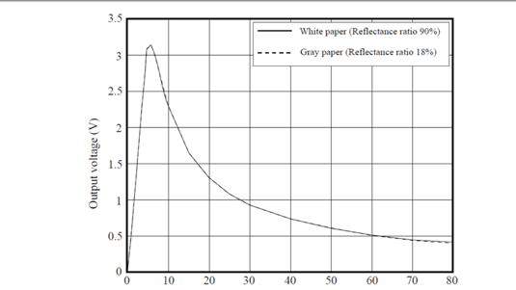

1. **Microcontroller approach**

This approach utilized floating – integer point manipulation ability of it for interpolating the values to get a as close as possible Curve Fit of the Sharp Data to obtain a function realizable on Microcontroller thus this was a good approach but had a very low level of Analog Understanding thus this approach was not taken probably because this was a mini project involving Single microcontroller thus the analog method was favored to incorporate further blocks in the Project.

1. **Analog Design**

This approach involved using the analog calculators building blocks that is the Opamps standard IC LM 741 these are versatile IC that can be modeled as basically

### Inverting amplifier

### Non-Inverting amplifier

### Differential amplifier

### Summing amplifier

### Exponential amplifier

### The first part of this style of approach involved collecting the data about our respective Sharp Sensors and entering it in the MATLAB or Matrix Laboratory which is a tool having very highly varied toolboxes preferred by scientists etc . We made two vectors of Distance and Voltage repectively in the script of the MATLAB and computed a curve fit of the data obtained using “CFTOOL” command in MATLAB .

### Accordingly we obtained the exponentials that we required to be implemented later for the compensator block explained below on the transcript .

### The second step involved generation of exponential Signal corresponding to the Input voltage driven by the Sharp sensor thus producing exponential corresponding to the Data received by the sensor . The circuit is shown below for reference the only problem involved with it was that it had to be scaled as Voltage produced was according to the diode current according to the e) setup of the opamp .

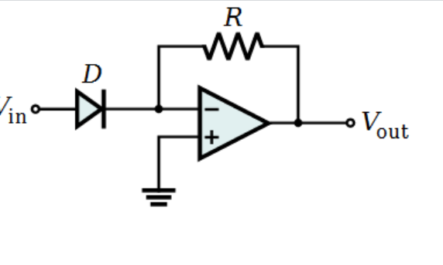

**CIRCUIT SETUP**

The relationship between Vout and Vin :-

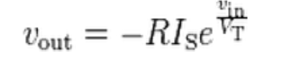

Where Is is given by the following formulae

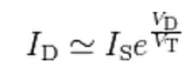

Thus we had to scale the coefficients as they were constants etc.

Thus in the form of basic coefficients our curve fitted exponentials had the form shown in the figure below



We found the following vector of values of Distance and Voltage repectively

D=[ 8.3 9.7 11 11.9 12.7 13.9 14.7 15.4 16.7 17.8 18.8 19.5 20.9 21.7 22.5 25];

V=[2.67 2.42 2.26 2.11 1.92 1.83 1.74 1.67 1.54 1.46 1.42 1.38 1.32 1.2 1.13 1.03];

The curve fitted out had the following values these are the values of the compensator block that if the non linearised data of IR sharp was provided to it the output would be a linearised function with distance that is voltage as a function of distance .

The values of the Compensator Block are

A= 3.101

B=-0.1731

C=2.714

D=-0.04

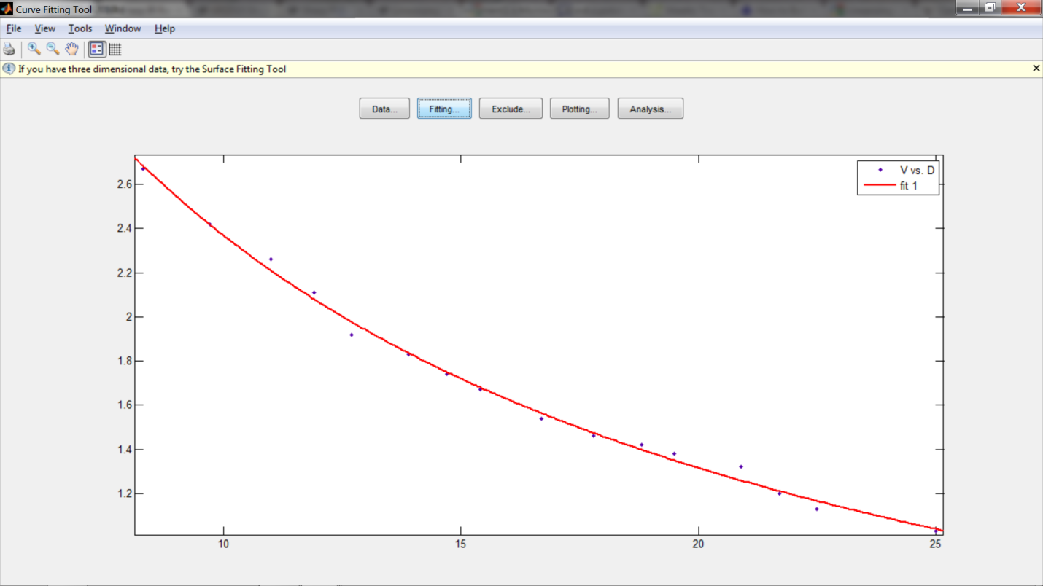

Thus our next goal involved getting the coefficients in order that is calculating the values of the various scaling coefficients that is the coefficients having various values for generating the required scaling that could have been achieved by using opamp multiplier circuit but a better option was for precision we used AD 633 IC that is a fixed precision multiplier IC but had a scaling of 10 on the output voltage to avoid saturation of the inbuilt amplifiers that is CMOS transistors etc .

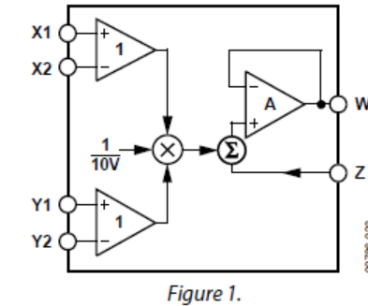

**FUNCTIONAL BLOCK OF AD 633**

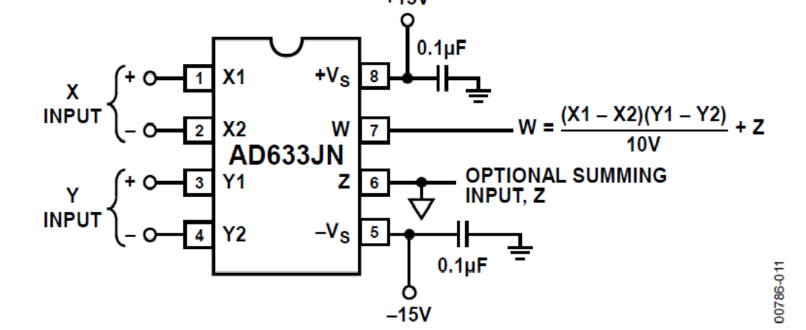

**CHIP PINOUT**

* The only connections required were to ground the 4 and 2 pins as well as 6 pin as it was not required to sum with any input .
* The above circuit was added to the first stage to generate the A,B or C,D coefficients of the Exponential required .
* The pins 1 had to be connected to the input and pin 3 to the scaling voltage .
* The pin 7 gives the output .

The next step involved generating the linearised function of voltage as distance that is a divider circuit for generating the exponential to negative power for generating the inverse function the divider circuit consisited of using the opamp and multilplier circuit for analog division and multiplication of some part of it that is the feedback loop of the circuit of Opamp involved multiplication using AD 633 .

Then process involved adding the another exponential signal generated to finally get the compensator function required thus the output of it would be a linearised function of distance as was required .

**CURVE OBTAINED**

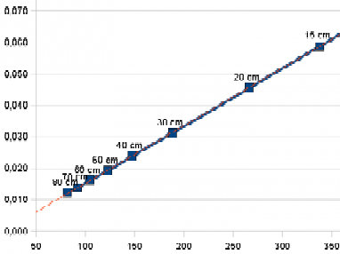

Thus are initial purpose of getting the a voltage linear with distance was served and can now be used in further stages .